Sierpiński Triangle Masterclass: Session Script

This icon means there’s a slide, or slides in the presentation to accompany this line of the script.

This icon indicates the students will have an activity to do, or something to write.

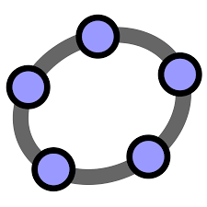
This icon means there is an accompanying Geogebra applet, listed in the resources for this session, which you can load in a browser.

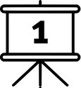
Welcome to today’s Masterclass. These Masterclasses are organised by the Royal Institution. Has anyone heard of the Royal Institution before? It was founded in 1799, and has always been about letting everyone have access to science - organising Masterclasses and lectures, including the Christmas lectures.

Many famous discoveries have been made in the Faraday building where they are based, including 10 chemical elements. Michael Faraday, who the building is named after, did work there on electricity and optics, which we all use every day.
The Ri are perhaps most famous for Christmas Lectures for young people, which have taken place since 1825. They have been televised for several decades, and many past series are available on the Ri website. The Masterclass programme was born out of the Christmas lectures delivered by Christopher Zeeman in 1978, which were the very first ones on mathematics!
There are many opportunities for you to visit the Ri building in London, and see the historic rooms for yourself. There is a small museum too. There are lots of talks and holiday events for young people: all the details are on the Ri’s website.

The title slide is repeated at the end of the introduction – if the Ri intro has already been shown in this series, you can start here.

Introduction (10 minutes)
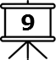
In this Masterclass session, we’ll be thinking about patterns.

- Can you name an example of a pattern that you have seen?

Patterns can appear on fabric, wrapping paper or wallpaper, and also in numbers, words and shapes. We’ll be looking at some example of patterns in this session, starting with a pattern in some numbers.
- Write down these few numbers: 1, 2, 4.

RESOURCES: Paper & pencil
Write down what you think comes next in this sequence, and think about why.

Some people have written 7, and some have written 8. Has anyone written anything different? Why did you choose that?
- If you chose 7, you were probably looking at the gaps between the numbers. The first gap is 1, then the next gap is 2. So if you had a gap of 3 next, the next number would be 7.
- If you chose 8 you may have noticed that the numbers double in size each time - 1 × 2 = 2, 2 × 2 = 4. So 4 × 2 = 8.

If you chose something else, you may have seen another pattern in the numbers. But can we be sure which of these is right? Mathematicians spend a lot of time looking for patterns, and if we see a pattern in an unexpected place, it can be very exciting. If you try to understand why the pattern is there, that can be very illuminating and lead you to more interesting maths.

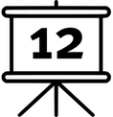
Next we’re going to look at a visual pattern, made using a simple set of instructions. This is called the Chaos Game. It isn’t the sort of game where you win or lose, but instead we’re going to create something interesting.

Chaos Game Activity (25 minutes)
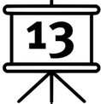
We’re going to make a pattern using iteration - repeating the same instruction over and over. We’re starting with a triangle, like this one.

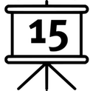
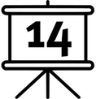
You start by choosing a corner of the triangle - and we can do this using a die. The die will land on one of the numbers 1-6, and each corner has two of those numbers written next to it. So, if we roll the die it will maybe land on a 4, and that means we start here.

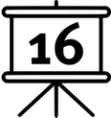
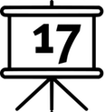
Next, we need to pick another corner. If it lands on a 3 or 4, we stay here, but if it lands on one of the other corners, say a 2, then we need to move from here towards that corner.

We’ll be moving exactly half the way there - so you’ll need to measure the distance using your ruler. If this distance was 20cm - then divide by 2 - what would that be? - and move 10cm along towards the new corner. This gives us a new starting point.

Then we repeat this again - so if we now rolled a 6, we’d move towards this corner and travel halfway along the line, and then if I now roll a 1 again we’d move half way here.

This is the pattern we’re going to follow to draw dots on the page.
- Before we start, can you imagine what the pattern is going to look like?
- Will the dots be spread evenly across the triangle?
- Will any dots fall outside the triangle?
- Are there any places in the triangle you won’t be able to draw dots?

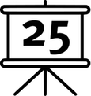
RESOURCES PER PAIR: Worksheet 1 on OHP transparency, six-sided die, 30-cm ruler, dry-wipe marker
Working in pairs, spend 5 minutes drawing dots and create a pattern on your sheet. Be careful if you’re using a dry erase marker that you don’t accidentally rub off your dots!

These sheets are all transparent, which means you can see through them. So if we collect them together and hold them behind each other, you can see more than one set of dots in the same place. Let’s collect all the triangles and place them in a pile, so we can see if there’s a pattern in the shape.

(Place an extra transparency on top, or use the top sheet to draw on)
Here in the centre of the triangle, there’s a space where there are no dots. Are there any other spaces without dots?

The pattern we’ve created here uses only the dots we’ve drawn in this time. How many dots did you draw? Around 10? Less than 20? So in this room altogether we won’t have more than a few hundred dots. What happens if we carry this pattern on and use lots of dots?
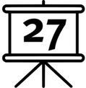
(Load the online Chaos Game geogebra applet via slide 26, or use the animation on the slide)

- How can we describe the shape that this makes?
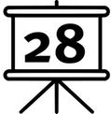
This shape is called a Sierpiński triangle.

The shape has a hole in the middle - there are no dots in this area. Why can’t any dots land here?
(use ‘half-way’ Geogebra applet via slide 29 to show where the halfway point lies between your dot and the corner you’re going towards)

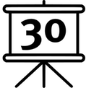
Wherever your dot is in the triangle, all the points that are halfway to the corner lie in this smaller triangle nearest the point you’re going towards, because this triangle is half as tall and half as wide as the big triangle. And depending on which corner you choose, you’ll always end up in one of these three triangles.

And if we’re not allowed to start from any points in the middle triangle, we’ll never get to any of the points in this smaller triangle here (and the same for each of the other corners).
And we can repeat this.

- Can we use this process of drawing dots to create the whole Sierpiński triangle?

If not, why not? The pen we’re using is thick - at some point the tiny triangles will be smaller than the dot our pen can draw, so we won’t be able to draw the whole triangle. Even if we use a thinner pen, there will eventually be a point where would stop being able to see the triangles.

Sierpiński Triangle construction activity (25 minutes)

Now we’re going to construct this shape using triangles, step by step. We’ll start with a big triangle, and draw in smaller triangles stage by stage, and use this triangular paper to help.

Construct a big triangle whose edges are 16 spaces long - you’ll need to start at the edge of the page. This is how we construct the first layer of the Sierpiński Triangle.

- How would you describe the rule for making the next layer of triangles?
- Why do you think we’ve chosen 16 as the length of the edge of the triangle?

We could describe the rule as ‘find the largest upright triangle and draw in the largest downward-pointing equilateral triangle’. This means we’ll need to construct a triangle that touches the middle of each edge of the triangle. If we’ll be splitting the edges of triangle in half each time, starting with a number that can be easily halved many times will make this easier.

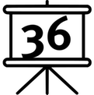
RESOURCES: Isometric paper/worksheet 7, pencil (students may wish to use a ruler but it’s easier to count the number of triangles)
Draw in this triangle now, and colour the central section to show it’s been removed. Now repeat this for each layer of the triangle, but use a different colour to colour in each size of triangle. Construct all the layers shown on the slide, and see if you can go further than this.

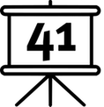
Now that you’ve constructed four or five layers of triangles, here are some questions to answer.

- Have you finished your drawing? If not, why not?

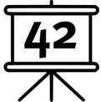
If you think you haven’t finished because a layer is incomplete, then imagine you have completed that layer. Now is it finished?

- Are there still spaces where you could colour in a triangle?
- When will this stop being true?

You might find your pencil is too thick to draw the lines, or your ruler doesn’t have small enough marks to measure the sides. But each time you draw a triangle, three more blank triangles are created, so you will never stop having triangles to draw.

We can stop once our triangles are too small to draw, or we run out of time, but if you imagine we had unlimited time, and could use smaller and smaller pencils, you could carry on forever. This is why the Sierpiński triangle is a fractal.

I can show you what happens if you zoom in on this Sierpiński triangle - it will keep zooming for as long as you like, because this is a true fractal and all the triangles have been removed all the way down forever.

Fractal Properties Discussion (10 minutes)

Fractals have special properties. Look at the drawing you’ve made, and fill in the table on worksheet to record all this information about your drawing. Let’s fill in the first two rows together.

The top row is for the first triangle you drew in. Use the colour you used for this to shade this box, then you know you have drawn one triangle, and what’s the area? 64.

RESOURCES: Fractal properties worksheet 2, pencil
Now carry on and fill in the rest of this sheet. Look for patterns in the numbers.

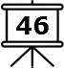
Each time, the number of triangles drawn increases. You have 1, then 3, then 9, then 27, and did anyone count or work out how many triangles are in the layer after that? 81. Is there a pattern? Each time there are three times as many.

- Why do you think we need three times as many triangles each time?

Each time we draw a triangle pointing down, we create three triangles pointing up. So the next layer will need a downward pointing triangle in each of these spaces. The number of triangles will always carry on getting bigger.

What about the area that’s coloured in? The size of each triangle gets smaller, but the number of triangles increases. Does the size of the triangles follow a pattern? How does the area get smaller? It’s a quarter of the area each time.

Pascal’s Triangle Activity (long version - 20 minutes)
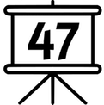
We’re going to look for patterns in a different triangle now. This one is called Pascal’s Triangle, and it’s filled with numbers.

RESOURCES: Small Pascal’s triangle worksheet 3 (either version), pencil
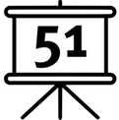
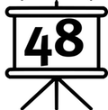
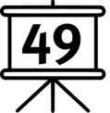
You should have a sheet with a blank grid of squares, arranged in a triangle. The number we’re going to put in each square is the number of ways you can get to that square, starting from the top of the triangle. But the rule is, you’re only allowed to move down the triangle, not sideways or up.

So, if you look at the top square, there’s only one way to get there. Similarly, the two squares on the second row also only have one way to get there - from this top square - so they also have a 1. But this square in the middle of the next row has more than one way to get there.

- Can anyone describe a way?

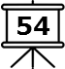
There are two possible ways to get here, but only one way to get to these side squares.

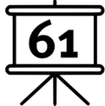
And we can carry on - the next row has 1 way, 3 ways (like these), then 3 and then 1. I can fill in the next row as well - 1, 4, 6, 4, 1.

But what’s interesting about these numbers is they also have patterns in them.

- Can you describe any of the patterns you see?

The numbers are always symmetrical; they are always 1 at the ends; they get bigger as you go down the side. There are many patterns here. But here’s another one, which we can use to help us fill in more of the numbers.

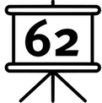
For each square I’ve filled in, look at the numbers in the squares above.

- Do you see anything interesting about the numbers?

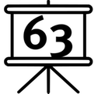
The two numbers above add up to the number below. This means, if you want to find out what number is in this square, I could find it by adding together these two numbers above. So what would this one be?

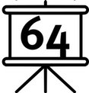
Now you have a few minutes to fill in some more rows of Pascal’s triangle on your sheet.

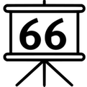
Next we’re going to create another pattern in this triangle, and this time we’re going to use colours. I want you to look at the numbers you’ve drawn, choose a colour, and use it colour in all the even numbers in this triangle.

- Do you see a pattern in the numbers you’ve coloured in?

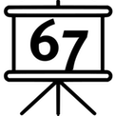
If you’ve correctly coloured in only the even numbers you should be able to see a pattern emerging - it’s the Sierpiński triangle again!

Now that we’ve seen an interesting pattern, we’re going to investigate why this happens. The colour of the squares depends on whether it’s odd or even, but the value of the number depends on the two numbers above.

- If we add together two even numbers, will the answer be odd or even? Try some examples and see what happens.

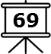
RESOURCES: Addition rules worksheet 4, pencil
Use this other worksheet to fill in the answers for all the possible combinations - even + even, even + odd, odd + even and odd + odd.

These rules will always work for any odd or even numbers we’re adding together.

- Do we need to know the numbers in order to colour in the pattern?

It doesn’t matter what numbers are in the squares - it just matters whether they’re odd or even.

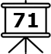
So we can come up with a set of rules for colouring in the triangle, using the two squares above. Use the four sets of blocks at the bottom to fill in what the rule will be for each colour, using a pencil.

Fill in the four rules in picture form. Can you write these rules in a simpler way? Use the space at the bottom.

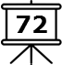
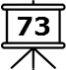
These rules are the same as saying that if the two blocks are the same colour, you shade the block below, and if they’re different you don’t. You can use them to colour in the triangle without using any numbers at all!

RESOURCES: Large Pascal’s triangle worksheet 5, coloured pencil
Start with three uncoloured squares at the top, and then you’ll find the pattern carries on the same - but you don’t need the numbers, and you can complete more rows. Use the next few minutes and follow the rules to colour in this larger triangle.

- One more question: why does this set of rules always give us triangle shapes?

If there are two odd numbers forming a flat edge horizontally, the rules tell us to start colouring below it. If there is an edge with a single coloured square, the rules tell us to colour in the square below, which makes the side come inwards. And if there are two coloured squares, the rules tell us to extend the triangle downwards.

Pascal’s Triangle Activity (short version - 10 minutes)
We’re going to look for patterns in a different triangle now. This one is called Pascal’s Triangle, and it’s filled with numbers.

You should have a sheet with a grid of squares, arranged in a triangle, with numbers in each square. The numbers have a pattern in them.

- Can you describe any of the patterns you see?

The numbers are always symmetrical; they are always 1 at the ends; they get bigger as you go down the side. There are many patterns here.

But here’s another one - for each square in the triangle, look at the numbers in the squares above.

- Do you see anything interesting about the numbers?

The two numbers above add up to the number below. This means, if you want to find out what number is in this square, I could find it by adding together these two numbers above.

RESOURCES: Completed Pascal’s triangle worksheet 6, coloured pencil
Next we’re going to create another pattern in this triangle, and this time we’re going to use colours. I want you to look at the numbers you’ve drawn, choose a colour, and use it colour in all the even numbers in this triangle.

- Do you see a pattern in the numbers you’ve coloured in?

If you’ve correctly coloured in only the even numbers you should be able to see a pattern emerging - it’s the Sierpiński triangle again!

End of session - recap
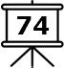
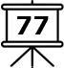
In this session we’ve looked at patterns in numbers; we made a triangle fractal by drawing individual dots; we drew our own triangles and found patterns in the sizes and shapes; and we found the same pattern again appearing in a totally different triangle of numbers.

When you leave here, always remember to look for patterns in the world around you, and when you see something interesting, investigate why!

If you have any questions about the Sierpiński triangle, we can ask the Ri and they will try to get back to us for the next Masterclass in the series. You have time now to put something about what you have enjoyed or what you would like to change about this session on your post-it note.

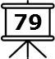
If you have enjoyed this topic and would like to explore it some more at home, here are some activities you can do online.

