Sierpiński’s Triangle
Thanks for helping with this masterclass session! Your support is much appreciated.

The session leader should be able to tell you more about the content of the session, and exactly how they’d like you to help, but this sheet should give you some basic information you may find useful. If any of this seems obvious to you, that’s great!

In general, for Masterclass sessions:
- While the session leader is talking to the group, don’t interrupt them or distract the students unless something is wrong that needs fixing urgently. You should also watch and pay attention to what they’re saying, to set a good example.
- If things need handing out to the students, wait for the session leader to signal you to do this, as it can distract the students if you start to hand things out before they’re ready.
- If the students are given a task to work on, you should circulate the room to talk to the students. Wait until they’ve had chance to tackle the problem before you interrupt them, and encourage anyone who looks like they haven’t started yet.
- Don’t give away the answers to the students - if they are really struggling, you can give them a hint or suggest where they might start looking.

In this session
This session is about finding and making patterns in numbers and shapes. We’ll construct fractals using a few different methods, and look for patterns that emerge when we follow simple rules.

Chaos game activity

This involves constructing a pattern of dots - rolling a dice to choose one of the three corners of a triangle, and each time moving half way from the last dot drawn towards the corner that was rolled. Students will be working on OHP transparency sheets, with a dry-erase marker pen, so that once everyone has drawn a collection of dots they can all be stacked and we can look through to see patterns in the arrangement of dots.

The students will work in pairs, so they can divide the work of rolling the dice/measuring the distance/calculating half that distance/marking a new dot each time.
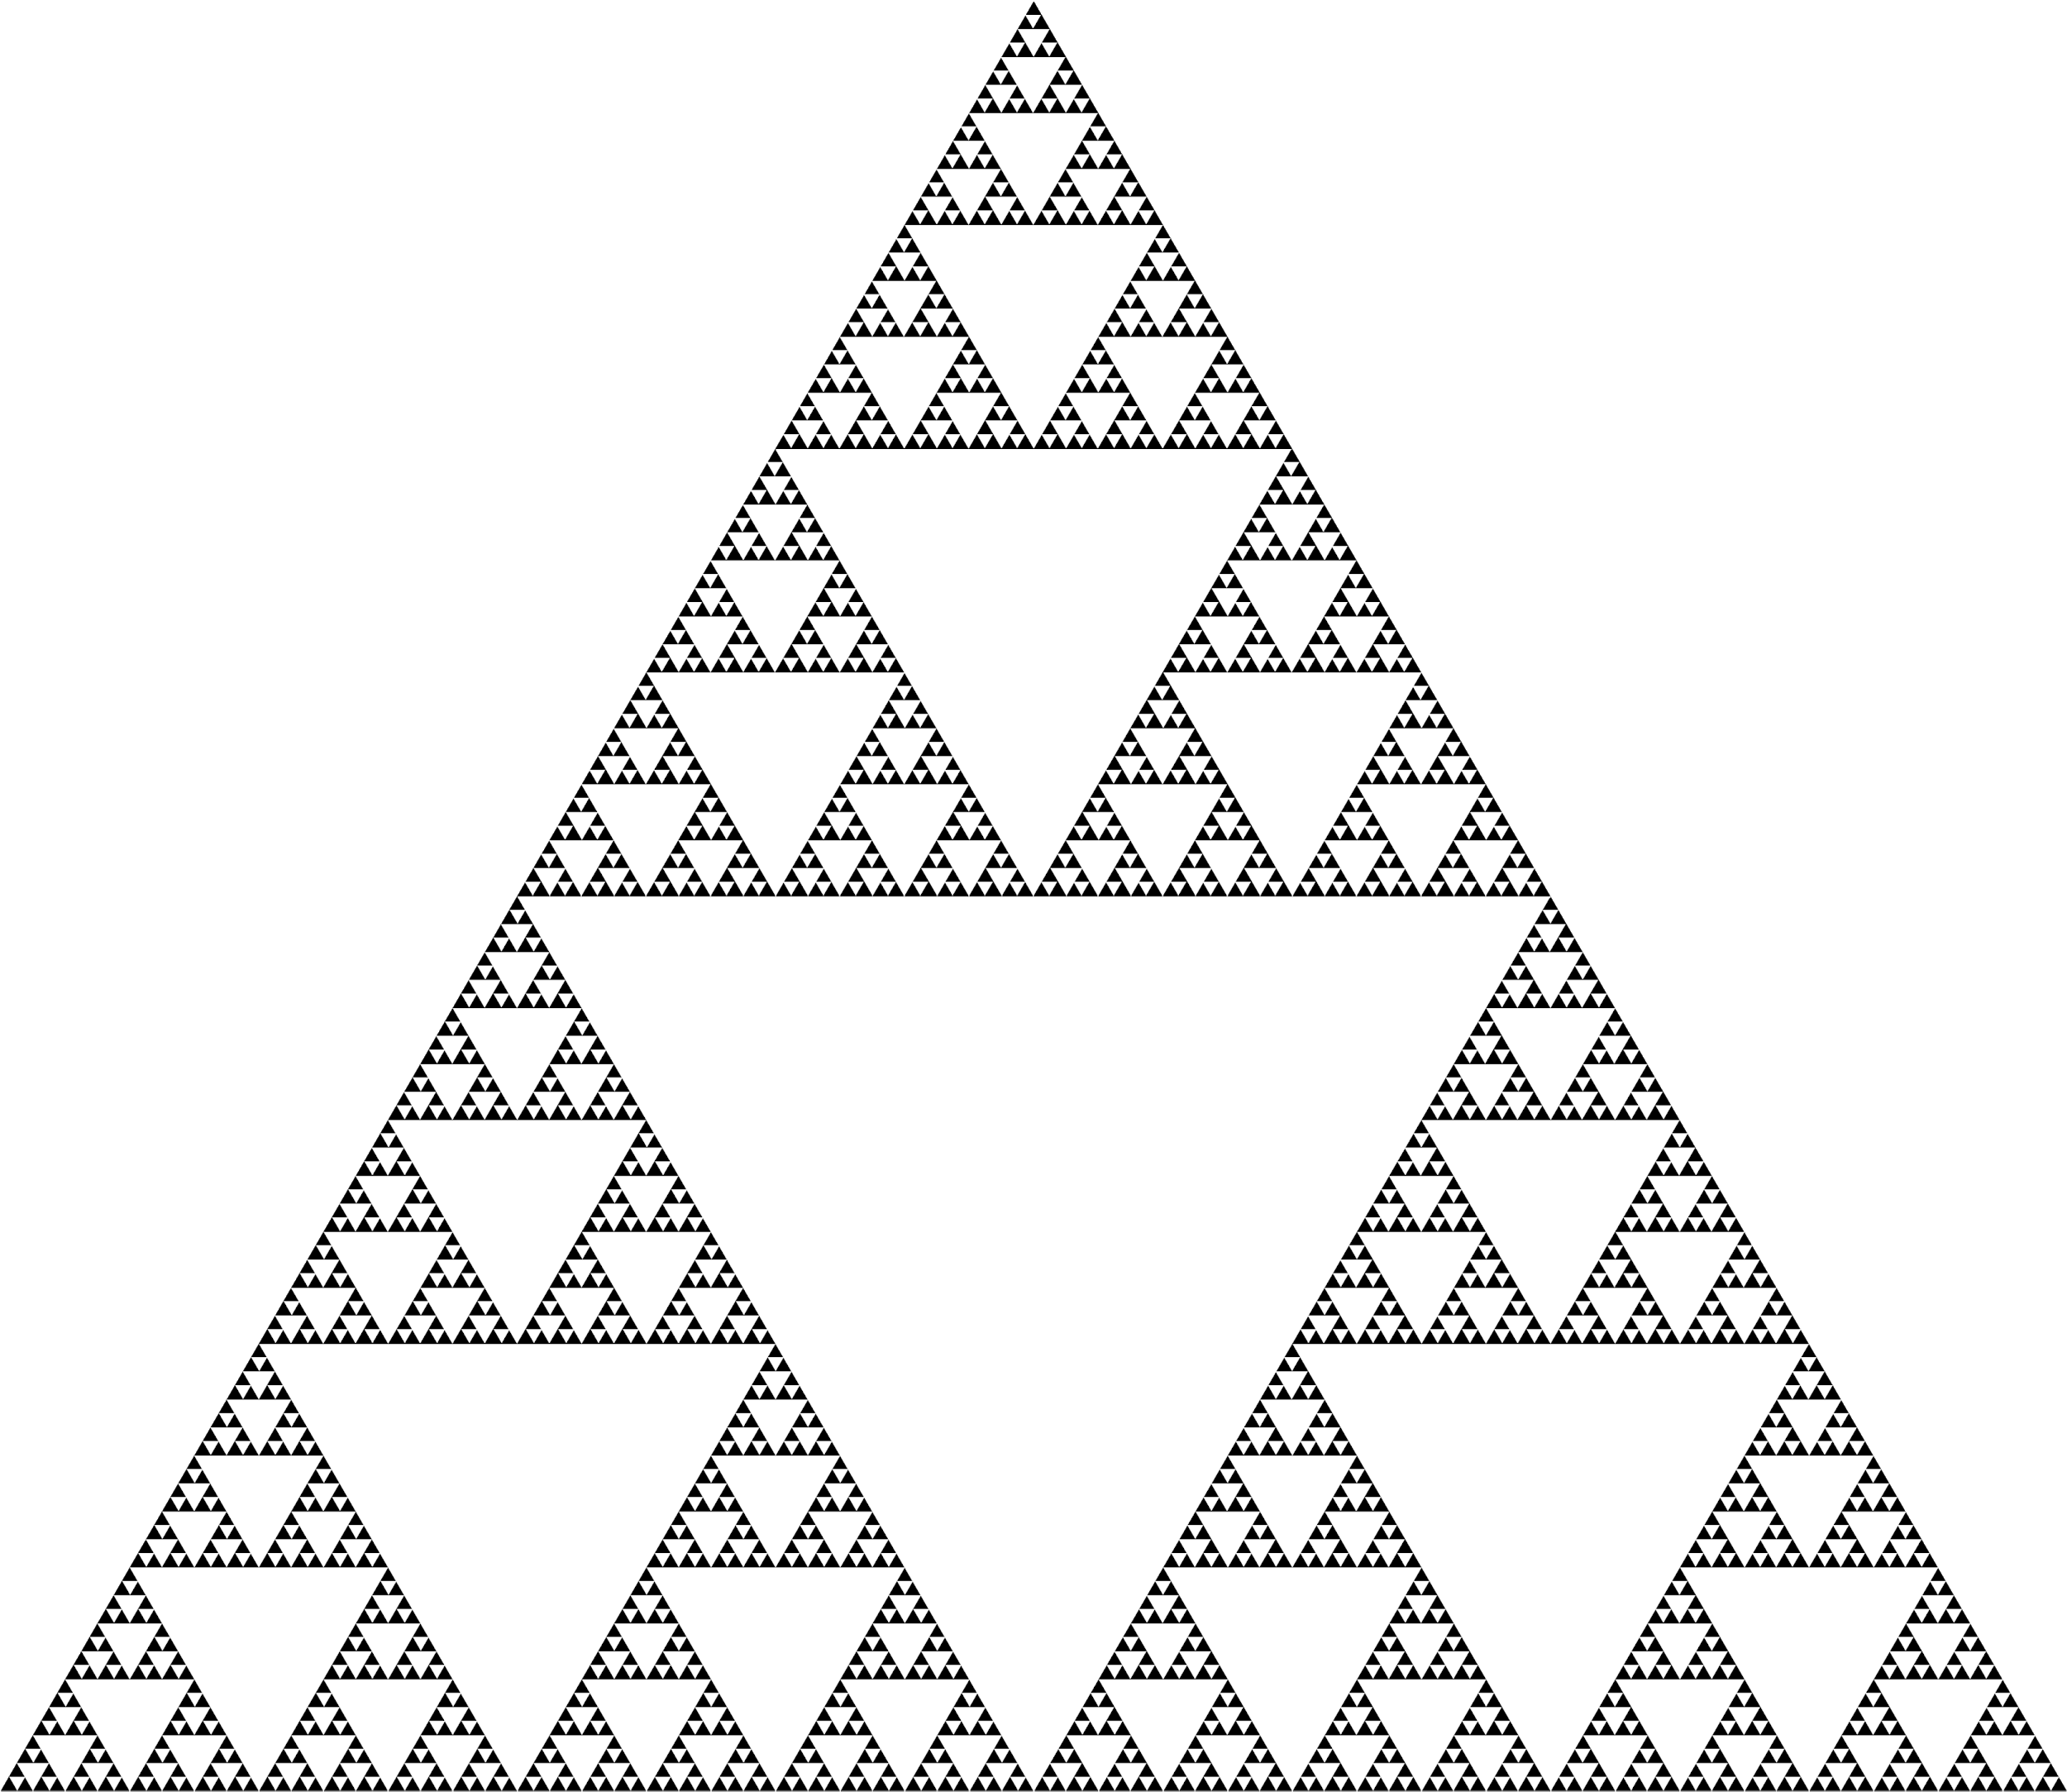
If the activity works correctly, the dots should lie only on the Sierpiński triangle - a fractal with a triangular hole in the centre, and each of the remaining triangular sections also has a triangular hole, and so on (see diagram). If anyone looks like they are drawing dots outside of this shape, you should check they’ve understood the method properly.

They may also need help working out what ‘halfway’ is for a given distance - they can approximate this, as long as the dot lies in the centre of the line, but they may struggle with measuring accurately, or dividing a value which isn’t an integer.

Students can continue drawing dots as long as the activity runs, so nobody should be finished before anyone else as they can just draw more dots.

Sierpiński triangle construction

The next activity is to construct a Sierpiński triangle by drawing triangles on isometric paper, starting with the largest triangle and working down. Students should colour in each central triangle section as it’s removed, and use a different colour for each size of triangle.

They have been instructed to start with a triangle whose side measures 16 spaces - this means the outside edge has 16 gaps along it, and not an edge measured by counting 16 triangles - as every second triangle points the other way, so this would be half the length. This will mean that halving the size of the triangle each time to construct the smaller triangles will merely involve counting rather than measuring. The triangles on the isometric paper may not measure an exact number of centimetres, so while students can use a ruler to draw straight lines, they won’t need to use the ruler to measure at this stage.

Students who complete the number of layers of triangles show on the slide can continue and construct extra layers - the smallest layer they will probably get to is a set of 81 triangles each ¼ units in area.

Fractal properties discussion

Having constructed a fractal, we will analyse the interesting properties it has by counting the number of triangles, and measuring the area of each (in units of the smaller triangles). Hopefully the students have used a different colour for each size of triangle, which will mean it will be easy to see how many are in each layer, and to count the number of smaller triangles in each.

Once the first two columns of numbers are filled, students can calculate the total area of each layer by multiplying together the numbers in the first two columns. Students who finish early should be encouraged to look for patterns in the columns of numbers, and should find the number of triangles triples each time, and the area is a quarter of the previous area.

Pascal’s triangle activity

The final activity in this session involves Pascal’s triangle - a triangle of numbers where each is the sum of the two numbers above. There are two versions of this - a short and a long version.

In the longer version of the activity, students are given the blank triangle and the number in each box is described as the number of ways to reach that box, starting from the top square, and only ever moving downward. This gives a 1 in the top row, and two 1s in the second row, and the first few rows will be completed as a group. Then students will be given the pattern of adding the numbers together and asked to complete the rest of the triangle. The session leader should have a completed version you can look at, but if you see anyone with an error higher up in their triangle, this will propagate down so make sure you point it out by asking ‘is this one correct?’, before they waste much effort on lower squares.

Once the triangle is completed, students will be asked to colour the even numbers in and this will give a pattern that is the same as the Sierpiński triangle. The last part of the activity is to notice that if the colouring only depends on if a number is odd or even, the rules for colouring don’t need to know the exact value of the number but only on its parity, so we can simplify the rules. There’s a worksheet for students to write out the rules for each of the four cases (odd/odd, odd/even, even/odd and even/even) and then to come up with a general rule, which is that if the two numbers have the same parity/shading, the result will be even, so the cell below must be shaded, and if they’re different it should not be shaded.

The shorter version of the activity involves giving the students an already completed triangle of numbers and asking them only to complete the shading and recognise the triangle.

Thanks again for your help with this session! If you have any other questions, please ask the session leader.

