Sierpiński Triangle Masterclass:
Extra Background Information
The Sierpiński triangle, sometimes also called a Sierpiński Gasket or Sierpiński Sieve, is a fractal based on an equilateral triangle. It is named after the Polish mathematician Wacław Sierpiński, although versions of it had been used as decorations since ancient Roman times.

Sierpiński was born in 1882 in Warsaw, and worked as a school teacher of mathematics and physics, before taking a job doing research in maths at university. He worked at the University of Lwow (which was in Poland at the time, but is now part of Ukraine) and at Warsaw University. He also spent time at the University of Moscow, during the First World War (1914-1918). He was a very successful and brilliant mathematician and published over 700 mathematics research papers. He had a wife named Anna, and two children. He died in 1969.
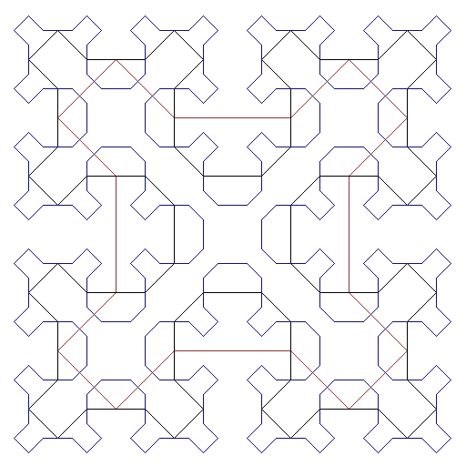
Sierpiński studied sets, including interesting shapes like fractals, as well as interesting numbers and sets of numbers. There are many fractal shapes named after Sierpiński, including the Sierpiński Carpet (which is a square version of the Sierpiński triangle), and the Sierpiński Curve, which is a type of curve called a space-filling curve - like the triangle, it can be drawn in a simple way and then more and more layers added to make it more complex, until it also has fractal properties. The image to the right (Wikipedia user Nol Aders, CC-BY-SA 3.0) shows three layers of a Sierpiński curve (the red line is the basic curve).

The Sierpiński triangle can be formed by repeating the process of removing the centre of a triangle, as in this workshop, or it can be made by starting from a square, and each time placing three copies of the shape in a triangular arrangement - then repeating this step. This process will also eventually give a Sierpiński triangle. There are other ways to generate this set, including the Pascal’s triangle method we’ve also done in this workshop, or using the Arrowhead Curve.

We can generalise the Sierpiński triangle to three dimensions, creating a Sierpiński tetrahedron, sometimes also called a Tetrix. This is a shape made by taking four tetrahedra (triangle-based pyramids), and attaching them at the corners to form a shape whose outline is the shape of a larger tetrahedron. This can then be repeated to form a Sierpiński tetrahedron.

Fractals, like the Sierpiński triangle, are always made using a repeated step, and at each stage the step is done in a way which means it can be done again. This means there’s always another step which can be done, and to make a true fractal you have to repeat the process infinitely many times. It’s not possible to practically do this in the real world - aside from the fact that it would take an infinitely long time, it’s often not practical in our physical universe to continue cutting away triangles beyond a given point - once you’ve removed one atom, or rubbed out the smallest area you can see, there’s no way to carry on. However, we can imagine the whole structure of the fractal and see that it could go on forever; or, imagine we started an infinitely long time ago and have now finished making it.

Pascal’s triangle is named after Blaise Pascal, who was a French mathematician. Pascal was born in 1623 in France, and was gifted at mathematics from an early age. As well as designing and building mechanical calculators, he researched many important areas of mathematics including geometry and probability, and in physics - studying hydraulics and the way fluids like water move. For this reason, the Pascal (a unit of pressure) is named after him. He suffered from poor health for most of his adult life, and died at the age of 39.

Many other things are named after Pascal, but one which we’ve studied in this workshop is Pascal’s Triangle. This is a triangle of numbers, which can be found by adding together two numbers to get the one below (starting with a 1 at the top and treating the edges as though they have zeroes), or by counting the numbers of ways to reach a square in the triangle moving only downward. There are also many other ways to calculate and use the numbers in the triangle, and it contains many interesting patterns.

Pascal wrote a ‘treatise’ - a long written document - on the triangle in 1653, describing the way the triangle is formed. Even though it’s named after Pascal, the triangle had been studied many times before by mathematicians in India, Iran, China, Germany, and Italy.

One of the main mathematical uses of the numbers in Pascal’s triangle is to give Binomial Coefficients - these are numbers made when you take a pair of numbers and multiply the pair by itself. For example, if you have the numbers x and y, you could write

(x+y) = 1x + 1y
(x+y) × (x+y) = 1x² + 2xy + 1y²
(x+y) × (x+y) × (x+y) = 1x³ + 3x²y + 3xy² + 1y³

Here you can see the second, third and fourth rows of Pascal’s triangle - 1,1; 1, 2, 1; and 1, 3, 3, 1. This pattern will always continue, and these kinds of equations have plenty of useful applications in mathematics.

You can also use them to calculate combinations of things. For example, if I have four different things and I’d like to choose two of them, there are many ways I could do this - I could pick things 1&2, or 1&3, or 1&4, or 2&3 and so on. For N things, if I want to choose M of them (where M is less than N), I can look at the Nth row of Pascal’s triangle and take the Mth entry, and this will tell me how many different ways I can choose. Remember that the top row of the triangle is considered the 0th row, so you need to start counting from 0 in the row and column.

There are many other interesting patterns in the triangle - for example, if you look at the sum of each row in the triangle, each row adds to a power of two, meaning each row adds up to double the row above. This makes sense if you consider that each number is formed by adding together two numbers from the row above, and that each number is added into the row below in two places - so everything is added in twice.

You can also see the triangular numbers - the numbers which can be drawn as a triangle of dots - if you look down the third diagonal stripe of the triangle (in either direction), which starts 1, 3, 6, 10...

Mathematicians do a lot of work on looking for patterns in numbers, shapes and anything else - by spotting interesting patterns, you can often see the underlying structure of the thing you’re studying. Once a mathematician sees a pattern, it’s often useful and important to check whether this pattern continues - for example, will the third diagonal row of Pascal’s triangle always give a triangular number? Can we check every number to see if it always works, or will it take too long?

By studying things carefully it’s often possible to prove that a pattern will always continue. But there are still problems like this we don’t know the answer to - the Riemann Hypothesis is an example of a famous mathematical pattern in the prime numbers - while all the numbers we’ve checked follow the pattern, we can’t be sure the pattern will always continue without checking all the possibilities, but that would take infinitely long. Someone will have to prove it!

