Magic Squares Masterclass
Magic squares are amazing things. If you aren't sure what a magic square is, it's a square grid of numbers containing all the numbers 1, 2, 3 and so on, each one exactly once. What's more, each row, column and diagonal of a magic square must add up to the same number!
People normally say there is only one 3x3 magic square. In one sense this is true, in another it is not. It is true because all the 3x3 magic squares are related by symmetry. Once you have one, you can get all the others by turning or flipping the one you found.
The table below shows all the 3x3 magic squares.
 | 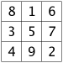 | 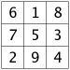
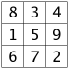 |  |  | 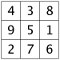
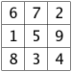 |  |  | 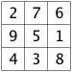
 | 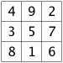 | 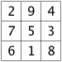
Legend of the Lo Shu
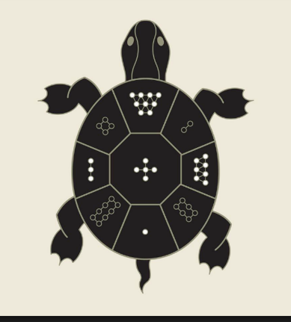
There is a legend from ancient China: at one time, there was a huge flood. The people tried to offer sacrifices to the god of one of the flooding rivers, the Lo River, to calm his anger. As they were doing this, a turtle emerged from the water with a curious pattern on its shell, with patterns of circular dots arranged in a three-by-three grid on the shell, such that the sum of the numbers in each row, column and diagonal was the same: 15. The people were able to use this magic square to control the river and reduce the flood. Just how old this story is is hard to tell. Early records are ambiguous, referring to a "river map", and date to 650 BCE, but clearly refer to a magic square by 80 CE, and explicitly give one since 570 CE

4x4 Magic Squares
Progressing on from 3x3, using the numbers 1-16 instead. In contrast to the unique solution of the 3x3 grid there are no less than 880 different (not including rotations and reflections) solutions to the 4x4 problem.

Magic Square from Albrecht Dürer’s “Melancolia I”
Albrecht Dürer (1471-1528) is a painter and printmaker, and is generally regarded as the greatest German Renaissance artist. His vast body of work includes altarpieces and religious works, numerous portraits and self-portraits, and copper engravings.
Dürer's magic square is a magic square with magic constant 34 used in an engraving entitled Melancolia I by Albrecht Dürer. The engraving shows a disorganized jumble of scientific equipment lying unused while an intellectual sits absorbed in thought. Dürer's magic square is located in the upper right-hand corner of the engraving. The numbers 15 and 14 appear in the middle of the bottom row, indicating the date of the engraving, 1514. Mathematical knowledge is referenced by the use of the symbols: compass, geometrical solid, magic square, scale, and hourglass.
Dürer's magic square has the additional property that the sums in any of the four quadrants, as well as the sum of the middle four numbers, are all 34 (It is thus a gnomon magic square) In addition, any pair of numbers symmetrically placed about the centre of the square sums to 17, a property making the square even more magical.
Magic Square from the Passion façade of Sagrada Familia, Barcelona (Sculptor: Subirachs)
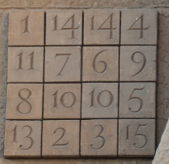
In the beautiful city of Barcelona you can visit one of the biggest of Gaudí’s (1852-1926) architectural achievements: the world renowned, and still incomplete, Sagrada Família. From a mathematician’s point of view it is great to take a closer look at the sculpture of Judas’ betrayal on the Passion Façade; right by its side you can find embedded a 4 x 4 the magic square. It is not-so-subtlety different from the 4 x 4 magic square already studied from Dürer.
One of these symbolic details sculpted by Subirachs involves an altered magic square. In the scene, portraying the kiss of Judas, a 4×4 grid of numbers is positioned on the wall behind the two embraced figures. Although not a true magic square because the grid contains the duplicate numbers of 10 and 14, it does consist of a magic constant. The number 33, representing the years of Christ’s life, can be found by adding any row, column, or diagonal from the square.
Subirachs’ square consists of many of these same features as Dürer's. However, Subirachs chose to create a square with the magic sum of 33. To fashion such a square, four of the numbers are reduced by one. The numbers 12 and 16 become 11 and 15, while 11 and 15 become 10 and 14. Numbers 12 and 16 are therefore missing from the square, while 10 and 14 have become duplicated. Having made these alterations Subirachs then rotated Dürer's magic square through 180°. Another “wow” moment for the Masterclass!
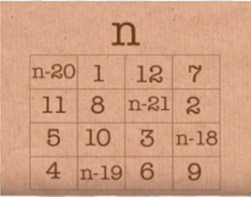
Random Total Magic Square
This is a nice party trick. A very few children will realise that the trick works because the number subtracted from “n” is equal to the numbers added when you take a particular column, row or diagonal.
Most children will need help manipulating the algebra. If they choose a low value of n then they will end up with negative numbers; n needs to be 21 or greater to avoid this. But it can be an extension/discussion point.
A Special Date Magic Square
This is a great activity for students who want to do some more algebra. This is more difficult in that there is not one right answer, as in several places they are invited to split a total however they wish. If they split the total very unevenly, they are likely to end up with negative numbers, so this could either be avoided, or discussed.

