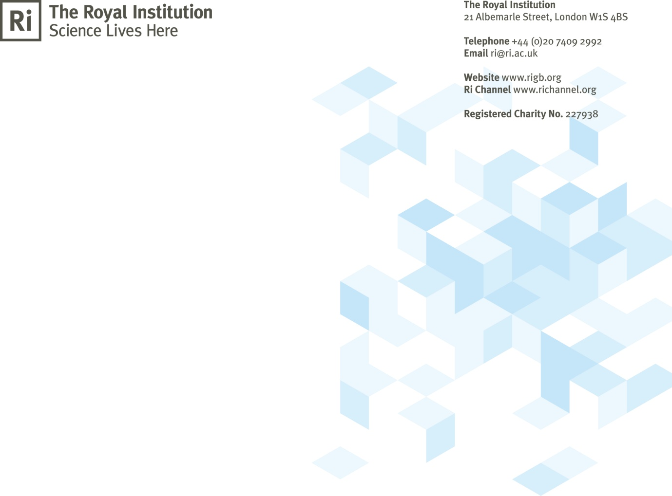

Application form for role as Masterclass
Helper

PRIVATE AND CONFIDENTIAL
Please note that the Ri will keep the information that you have given us in compliance with the Data Protection Act 1998. We will use the information on this form to contact you about Ri volunteering opportunities.

Name: Ri member: Yes/No
DOB: Email address:
DBS checked: Yes/ No If yes are you signed up to the updates service: Yes/No
1. Please list below any experience you have working with children and young people, with dates and duties:
Dates | Organisation/event/project name | Your duties/role

2. Please detail your availability for helping at the Masterclasses: (weekends/weekdays, am/pm, locations)

3. Please give the contact details of two referees who we can contact for a reference. If possible these referees should be able to comment on your suitability to work with children.

Referee 1
Full Name
Position held/job title
Contact email address
Contact phone number
Capacity in which you know this person

Referee 2
Full Name
Position held/job title
Contact email address
Contact phone number
Capacity in which you know this person

4. Please confirm whether you have any particular access/mobility requirements or whether you require any reasonable adjustments to participate in volunteering activities (e.g. avoid stairs or lifting)

