How many squares are there?

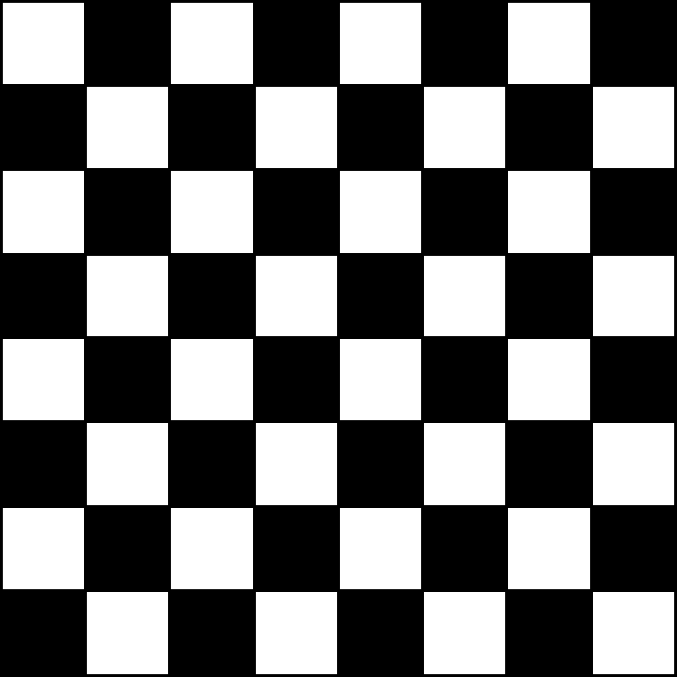

How many squares are there?

