Counting Triangles 1
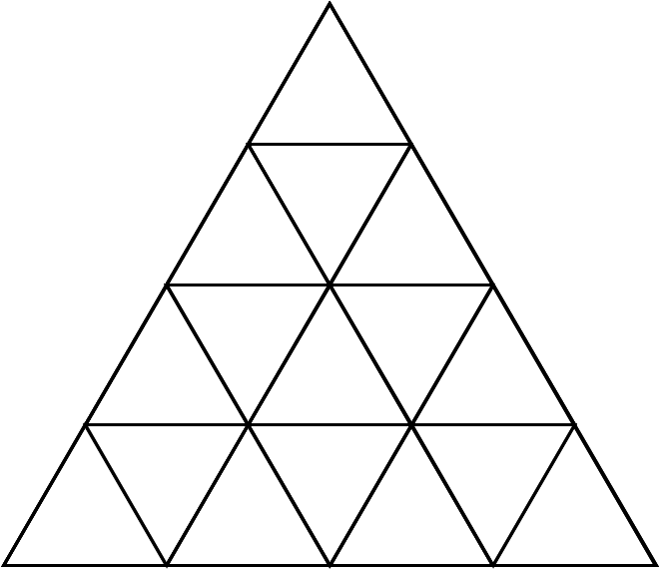
How many triangles can you count?

Counting Triangles 2
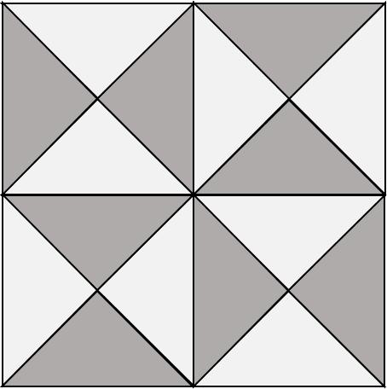
How many triangles are hidden in the pattern?
What strategy might you use to count them all to ensure you don’t miss any out?

