Ri Off the Shelf Masterclass: Bats to Bytes

Worksheet 1 – Batting Challenge Data Collection

Take it in turns to swing the bat for each of the three types of shot: a straight drive, a defensive block, and a pull shot. For each attempt, record the type of shot, then analyse the data from the micro:bit. Each person in your team should give their opinion on which graph the data matches the closest. Once everyone in your team has completed each shot, decide as a team which type of shot is shown by each graph.

|  |  |  |  |  |
| --- | --- | --- | --- | --- |
| **Batter Name** | **Type of shot**  *(Drive / Block / Pull)* | **Which graph does the data match the closest… A, B, or C?** | | |
| **Person 1** | **Person 2** | **Person 3** |
|  |  |  |  |  |
|  |  |  |  |  |
|  |  |  |  |  |
|  |  |  |  |  |
|  |  |  |  |  |
|  |  |  |  |  |
|  |  |  |  |  |
|  |  |  |  |  |
|  |  |  |  |  |

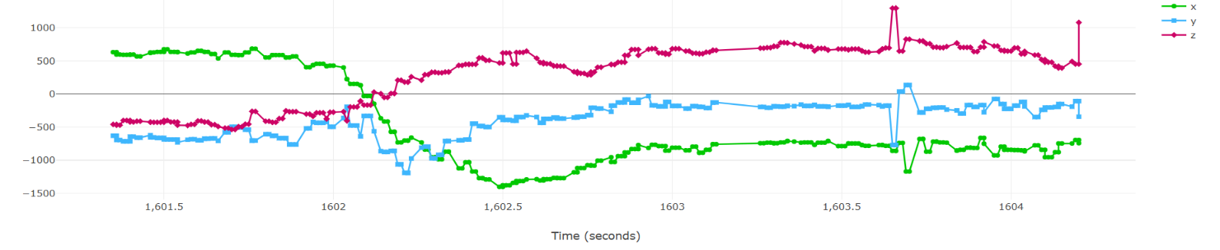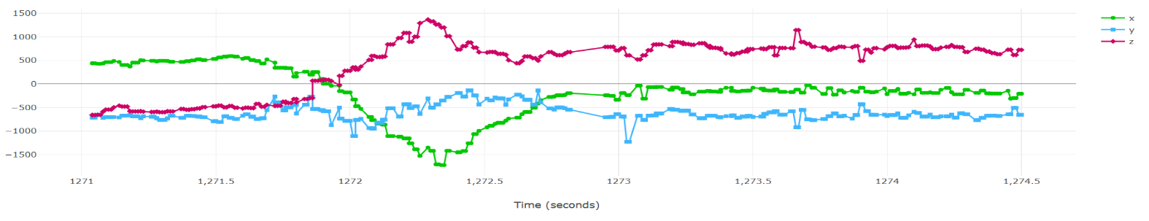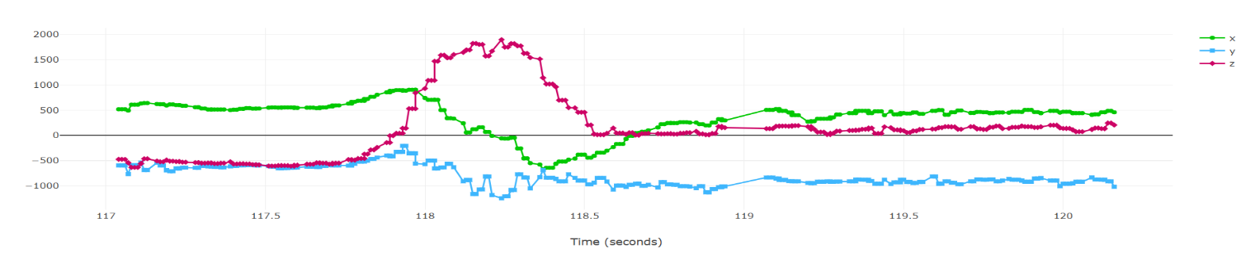

Above is Graph B. We think Graph B shows a ……… …………………………………**pull**…….. shot.

Above is Graph A. We think Graph A shows a ……………**defensive block**…………………………….. shot.

Above is Graph C. We think Graph C shows a …………………………**straight drive**……….. shot.