Charity Commission

Charities: The Mond Trust (227938 – 05) and Neate Endowment (227938 – 07).

The Commission proposes to make a Scheme (a legal document) for these charities. The Scheme will modernise the Mond Trust and extend the application of its income, it will enable the capital and income of the endowment to become expendable. It will also merge the Mond Trust and the Neate Endowment. A copy of the Scheme can be seen at www.charitycommission.gov.uk/our-regulatory-work/how-to-comment-on-a-scheme/schemes-and-orders/ (If you cannot access this please call our Contact Centre on 0300 066 9197).

Comments or representations on these proposals can be made to the Commission within one (1) month from Monday 11th December by completing the form on our website. Please quote BNWJ/227938/C-055410.
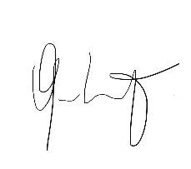

…………………………………………………..

Renato Lulia Jacob
Chair, The Mond Trust Committee

