Counting Squares

Size of chessboard: __________________________

Inner square size | How many fit along the chessboard/up the side? | How many on the whole board?

Size of chessboard: __________________________

Inner square size | How many fit along/up | How many fit on the whole board
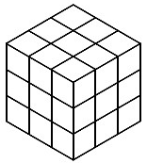
Counting Cubes

Size of big cube: __________________________
Inner cube size | How many fit along/up | How many fit on the whole board

Size of big cube: __________________________

Inner cube size | How many fit along/up | How many fit on the whole board

