

Proxy Voting Form
The Royal Institution of Great Britain – Charity No. 227938
Annual General Meeting (AGM)
to be held at 6.00pm on Wednesday 06 May 2026

If you are a voting Member and unable to attend the AGM, either in person or online, please designate a proxy for any agenda items that require a vote. You may do so by:

- completing the online or the QR code below:
- returning the completed form by email to governance@ri.ac.uk
- by post to: Governance and Risk Manager, Royal Institution of Great Britain,
21 Albemarle Street, London, W1S 4BS.

All proxy votes must arrive by 9.00am on Wednesday 06 May 2026.

Proxy votes are very important to us. They help to form a quorate meeting, without which we would not be able to conclude the charity’s business for the financial year. You may designate the Chair of the AGM to vote on your behalf, or any other Ri Member (as long as they are over 18).
_____________________________________________________________________________
Your name: Your membership number:

I declare that I am a Voting Member of the Royal Institution of Great Britain (“the Institution”).

- I hereby appoint to vote for me and on my behalf at the Annual General Meeting of the Institution to be held on Tuesday 06 May 2026 and at every adjournment thereof:

The AGM Chair (please cross in the box if choosing the Chair) ☐
or
Please state the name and Membership number of the member attending in person who will vote on your behalf or if you have selected the Chair to vote on your behalf, please go to b):

Their name: Their Ri membership No:
- Approval of the following proposal: Agenda Item 2 – Approval of the Minutes of the Annual General Meeting 06 May 2025:
For ☐ Against ☐

- Approval of the following proposal: Agenda Item 6 – Approval of the appointment of RSM as Auditors of the 2025-2026 Trustees Report and Financial Statements
For ☐ Against ☐

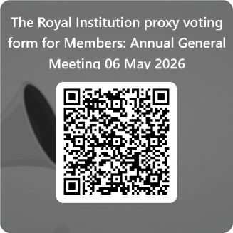
Signed:
(either an electronic or printed/typed signature is acceptable)

Dated:

