Ri Off the Shelf Masterclass: Football Manager
Worksheet 1 – Building a decision tree - Solutions
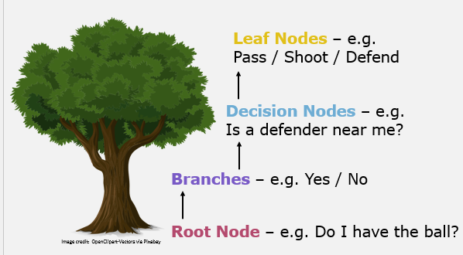
Decision trees have lots in common with real trees!
- For the decision tree below, label the root node, the branches, the decision nodes, and the leaf nodes. One has already been labelled for you. Once you have finished labelling, follow the route of the decision tree to find which football position may suit you best!


Branch
Do you like passing the ball?
Do you like running?
Defender
Goalkeeper
Yes
No
Do you like scoring goals?
Yes
No
Yes
No
Midfielder
Striker
Branch
Root Node
Branch
Decision Node
Branch
Branch
Leaf Node
Leaf Node

The position that suits me best is _ _ _ _ _ _ _ _ _ _ _ _ _ _
2. The decision tree below is missing some words. Get creative and complete the decision tree. When you have finished, follow the decision tree to the end to find which sport you may want to try.
Are you good at batting?
Do enjoy the outdoors?
Golf
Gaming
Yes
No
Do you prefer team sports or individual sports?
Team
Individual
Yes
No
Cricket
Are you better at catching or kicking?
Catching
Kicking
Football
Netball

The sport I should try is __________________________.

3. On a blank piece of paper, create your own decision tree. You could make a decision tree that decides:
- Whether or not to play football outside
- What to wear to football practice
- What snack to eat after playing a sport
- How to celebrate after scoring a goal
- Or your own choice!
You can make your decision tree as complex as you wish, but your tree will need to include at least one root node and one decision node.

